4. Go to C:/InstallNGL303 and Double click on Install batch file. This will Open command prompt and execute the scripts as shown below
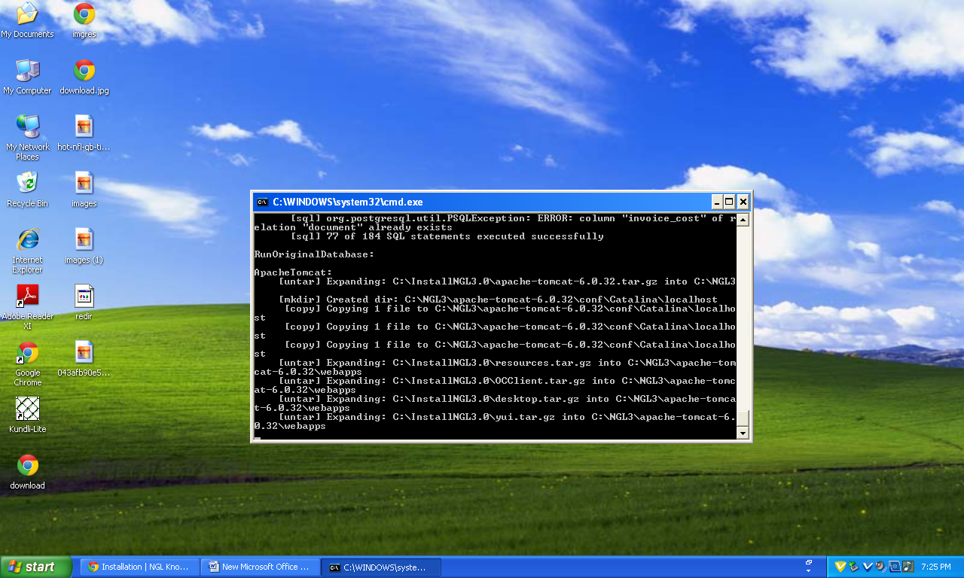
5. Go to C:/NGL3/apache-tomcat-6.0.32/bin directory. You can see a file RunNGL3Server batch file.
But dosenot shown run ngl 3server
