How to import Catalogue records from CSV file?

Step 1: To Download and install NGL Work Bench goto NewGenLib Wikia or Click here
To Download the NGL Work Bench files Click here.

>now goto C:\NGLWorkBench and double click on RunNGLWorkBench.bat. (Example: as shown below)
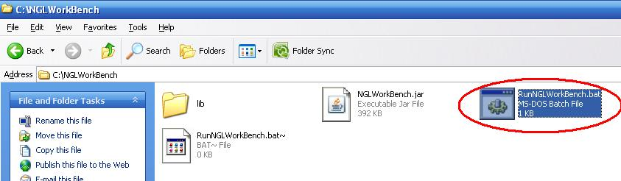

>A new window appears. (Example: as shown below)
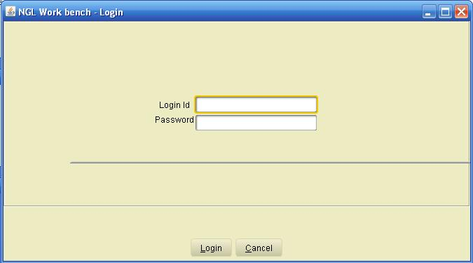
>enter the login id = 1 and password is default abc and click on login. (Example: as shown below)
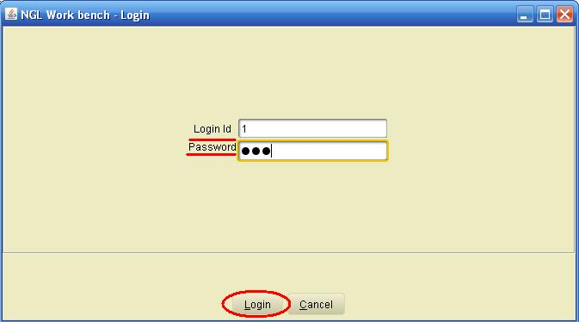
>goto utilities / Import Catalogue Records / from CSV file
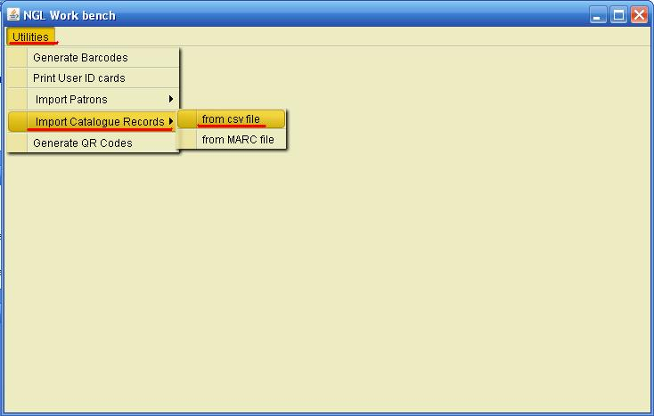
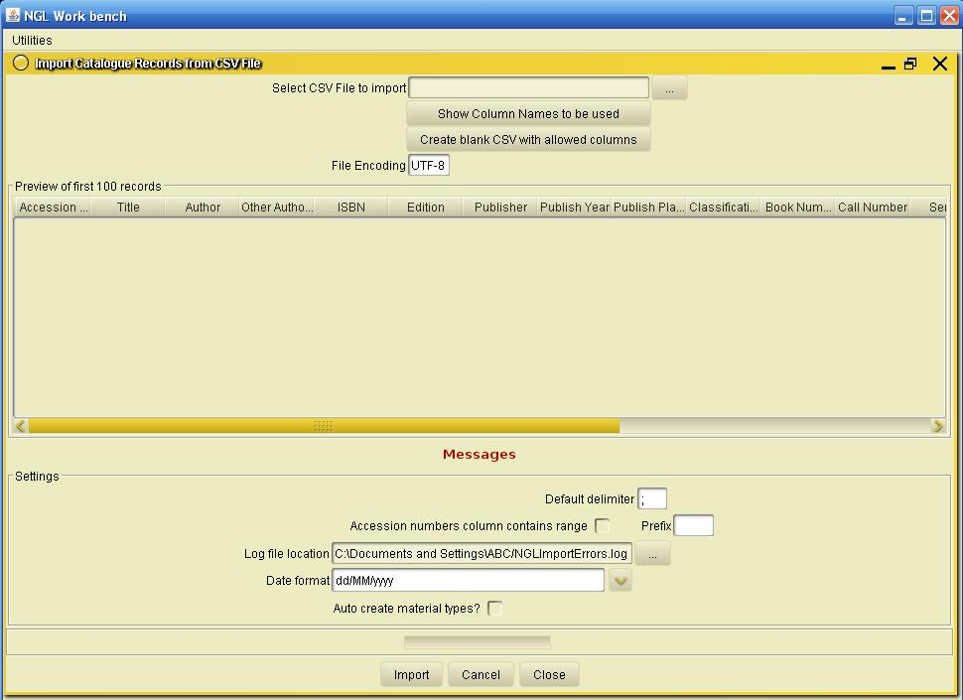
>Until now downloading and installing of NGL Work Bench is completed.

STEP 2:
Modify the CSV file with the proper Column Headings.
>In the NGL Work Bench window, there is an option Create blank CSV with allowed columns which generates a csv file with the appropriate column headings.
To edit the csv file there are two options:
Option A :
>Click on, Create blank CSV with allowed columns button
(Example: as shown below)
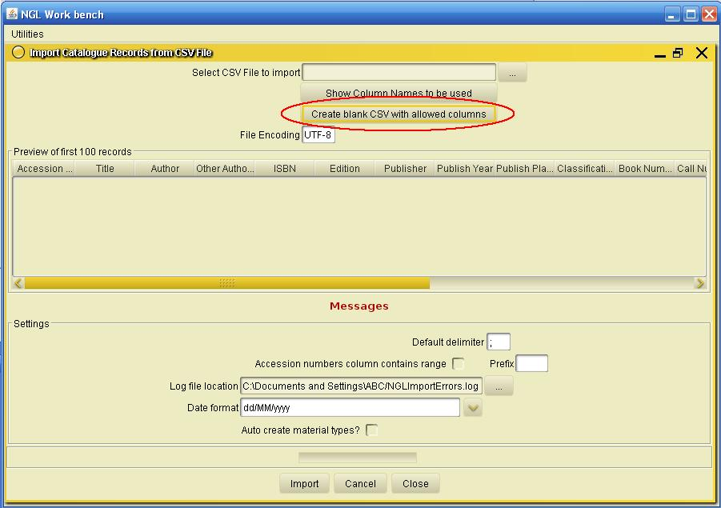
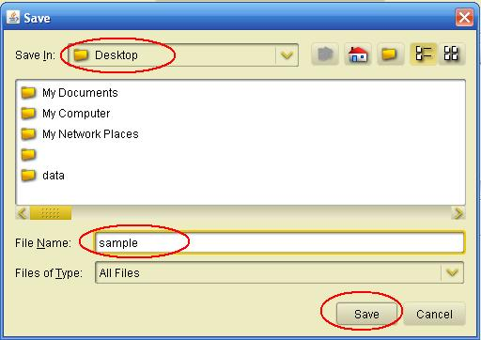
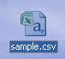
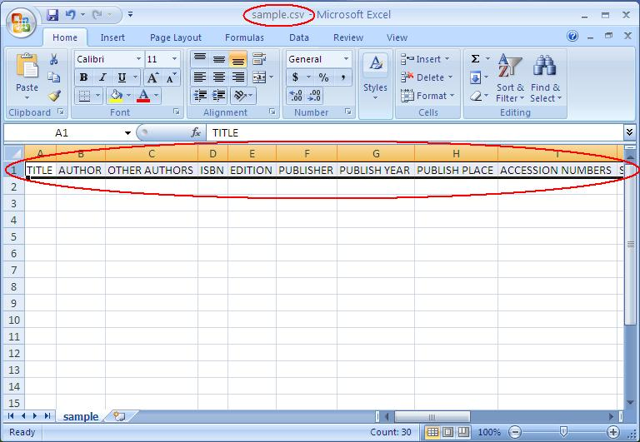
>Type in the data into the generated csv excel sheet.
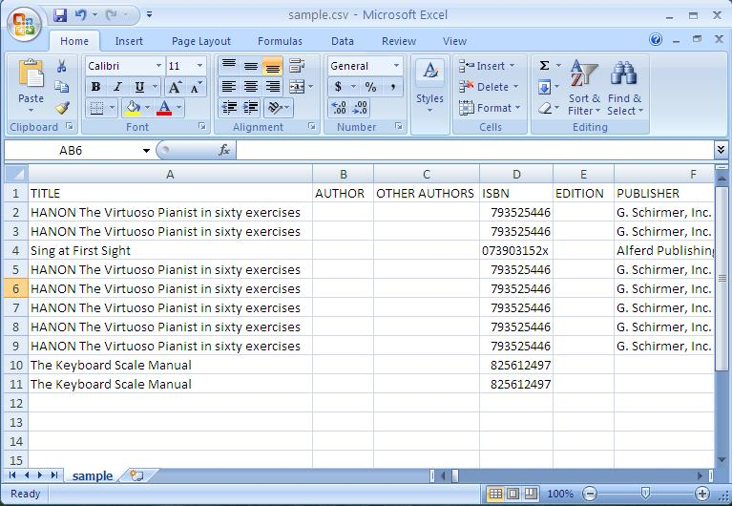
>Save the csv file.

Option B:
>If you already have data in excel sheet.
>Click on show column names to be used button.
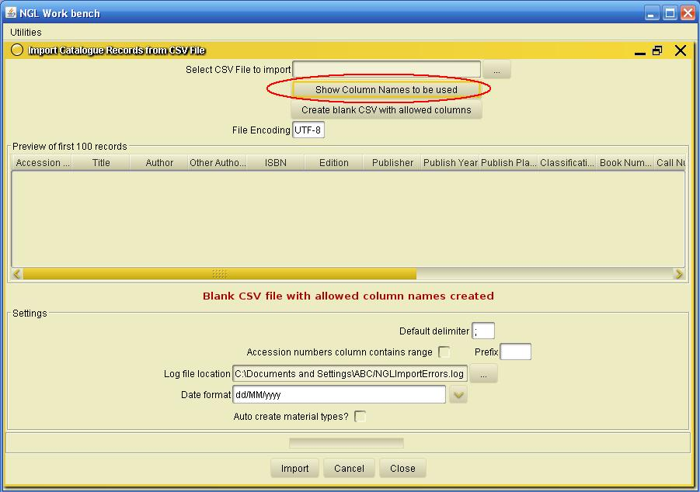
A window pops out with the respective column names. Copy the headings into the csv file.
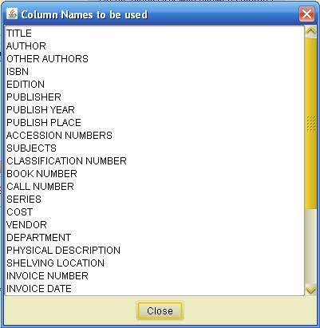
>copy the headings and rename in the csv file. (Example: as shown below)

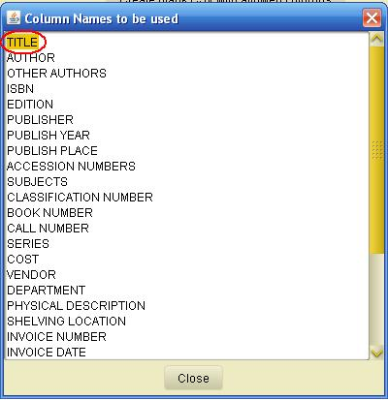
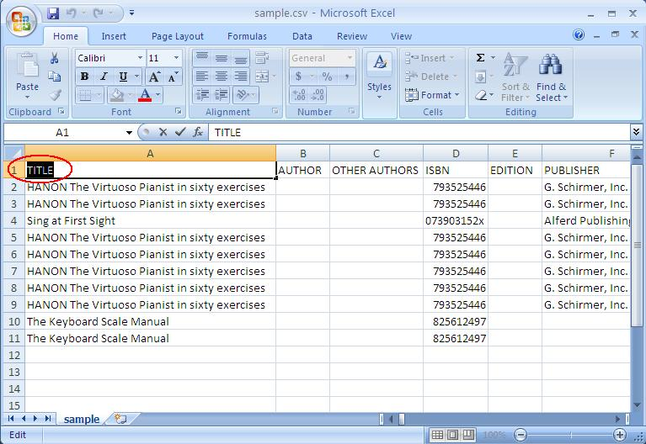
>Edit all the headings with the appropriate headings given by the tool.
Save the csv file.

STEP 3:
Import the CSV file.
>to import the CSV file, click on the browse button.
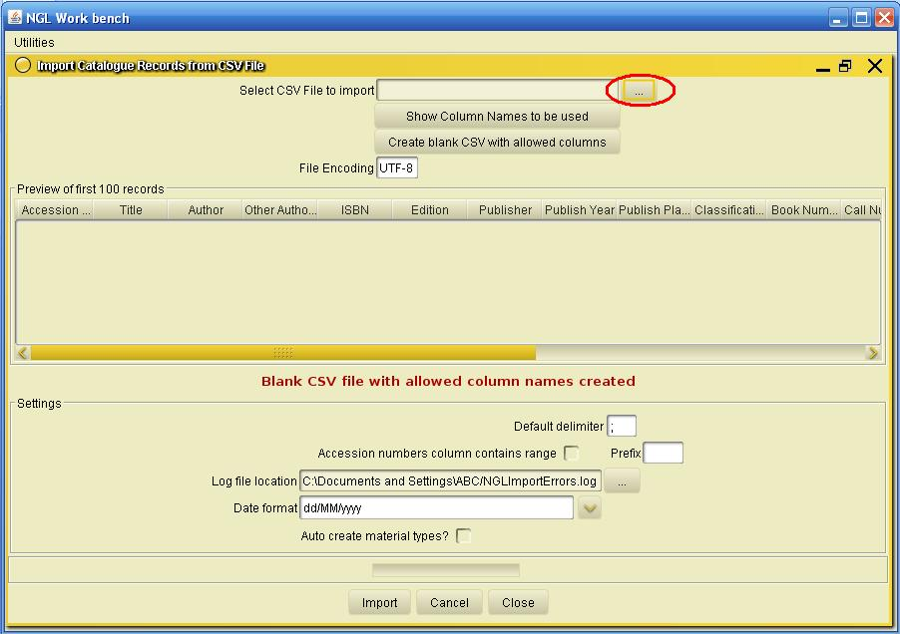
>A window pops out. Browse the sample.csv file (i.e., the edited csv file).
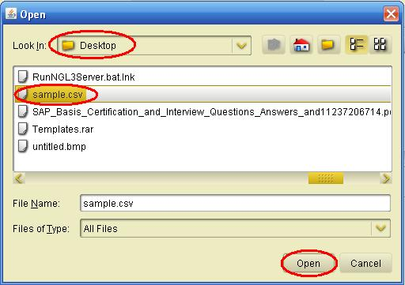
>after the csv file is selected, the application preview’s a sample of first 100 records from the csv file.
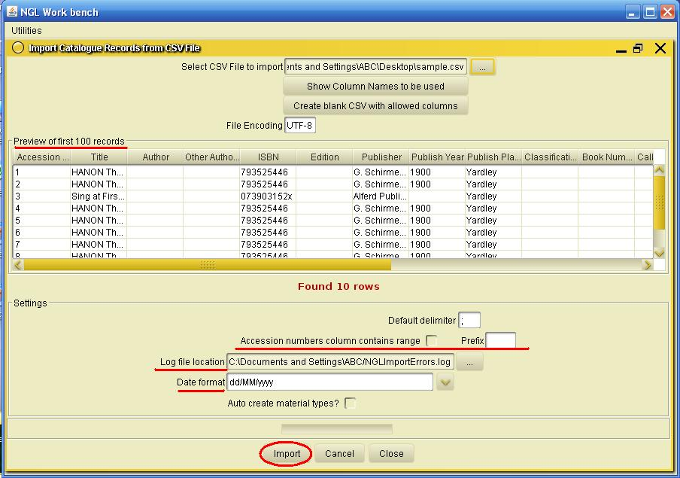
>Brfore clicking on the import button, check the following:
* If the accession no’s are given in a range in the csv file, make sure to check (select or tick) theAccession numbers column contains range box.
* select a path for the log file location which will help to filter the un imported records by the tool, which could be later edited and re-import or added manually into the database through the Application.
* select the appropriate date format as given in the csv file.
>Click on import button.
>after the import is complete, the tool leaves a message.
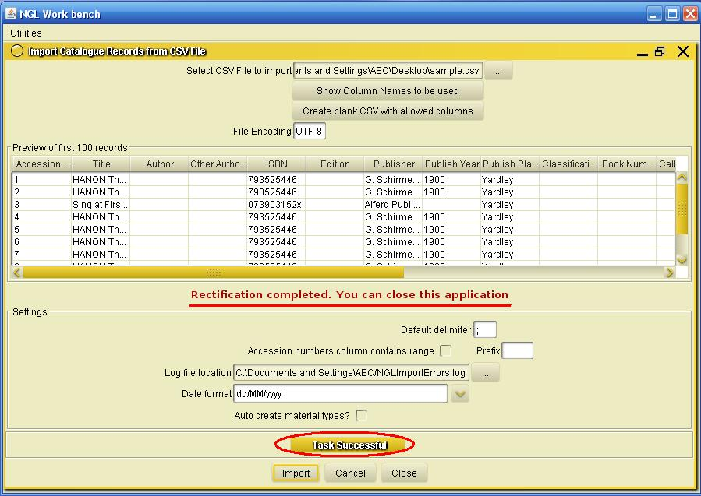

STEP 4:
Start the NGLServer and goto C:\Indexer and click on RunIndex.bat.
The index may take a while and once the index is done, the indexer exit’s by itself.
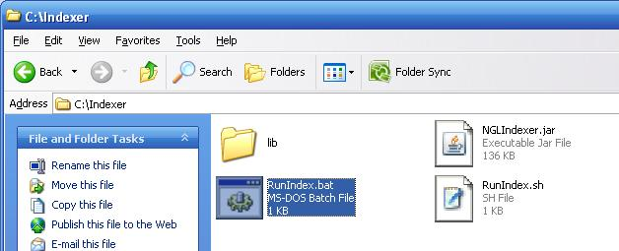

>Task successfully done.

