Technical Processing - Search Catalogue-search any accession number
Ex: 10101234 Click on Search button. --- Update holding
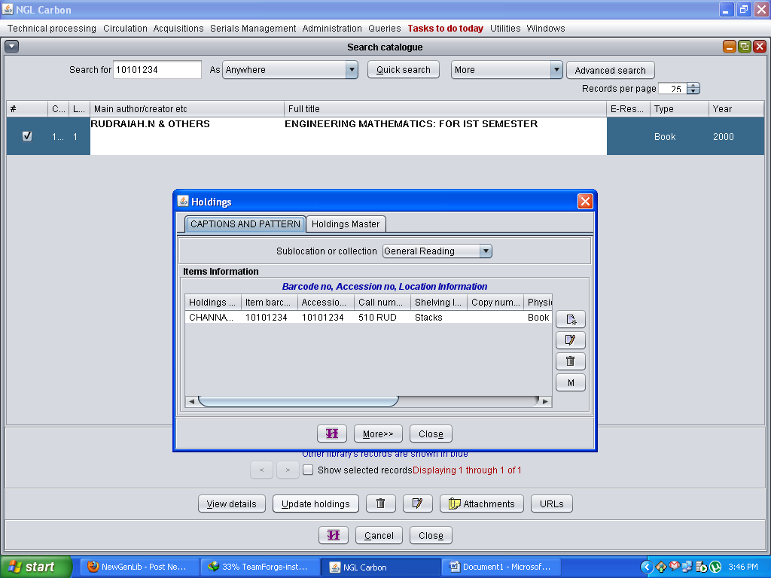

Click on Modify
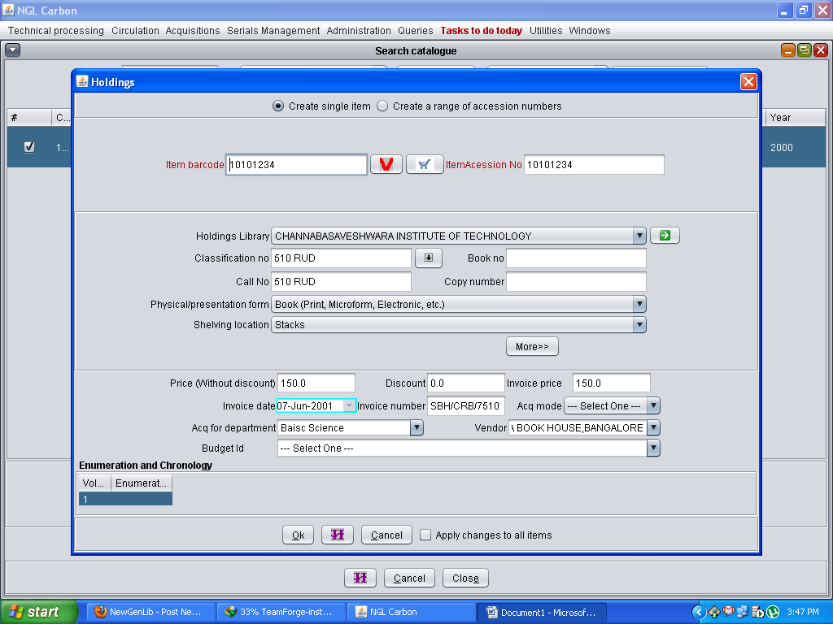
Error: Acq for Department, Vendor Existing these two drop down list but edit option is there.
Correct: Acq mode This option is good. Can’t editable.
Please check these options.
Check now previous window Acq for Department: Basic Science , below window edit option Baisc.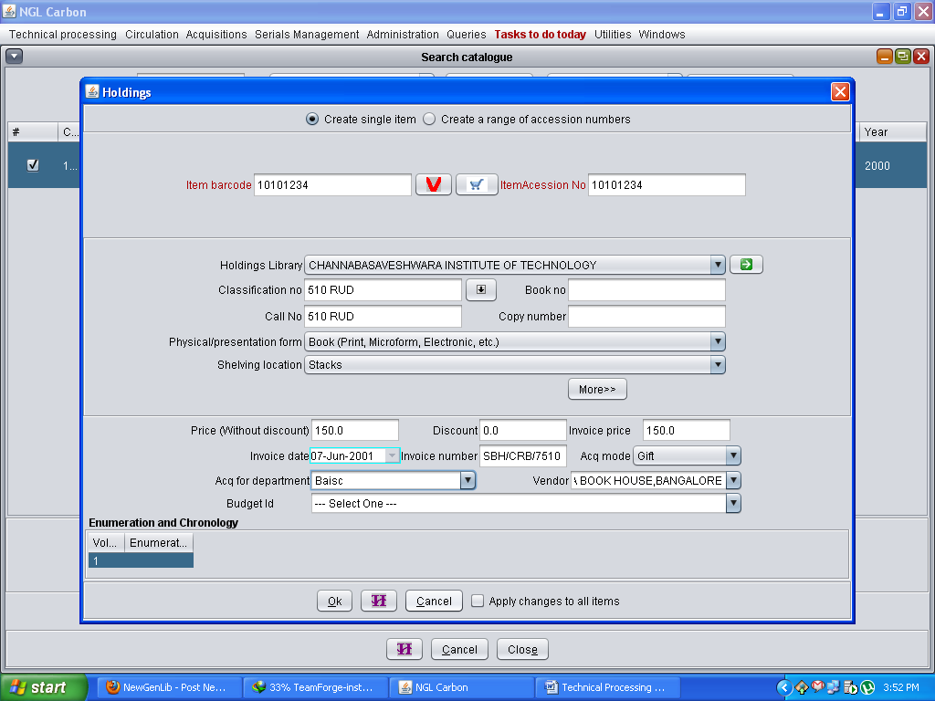
This is effect to reports: Prepare customized list.

