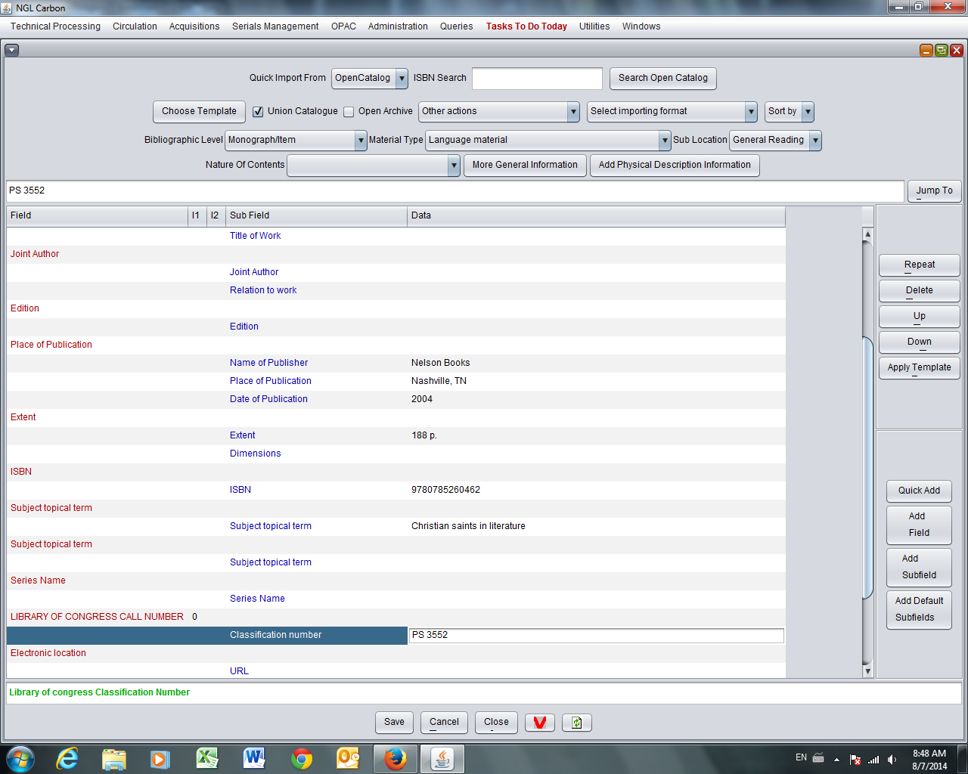
Screen A: Note: Classification number PS 3552
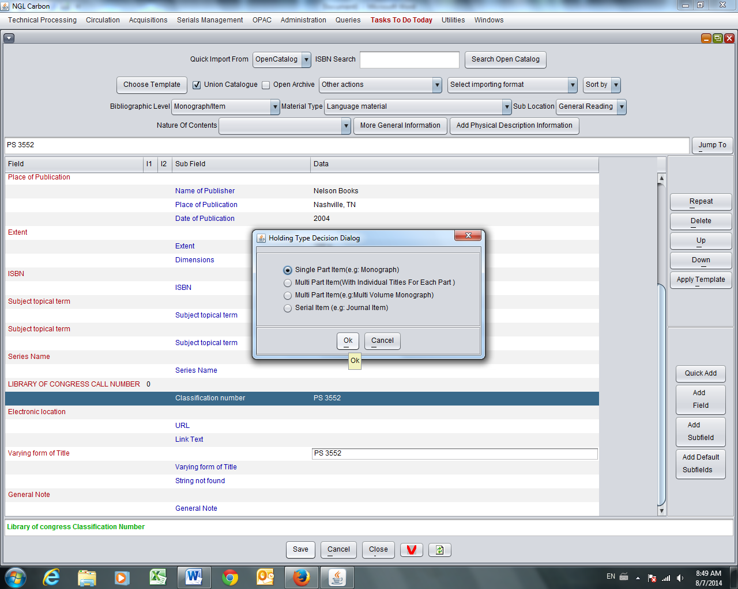
Screen B: Saved, to add Holding
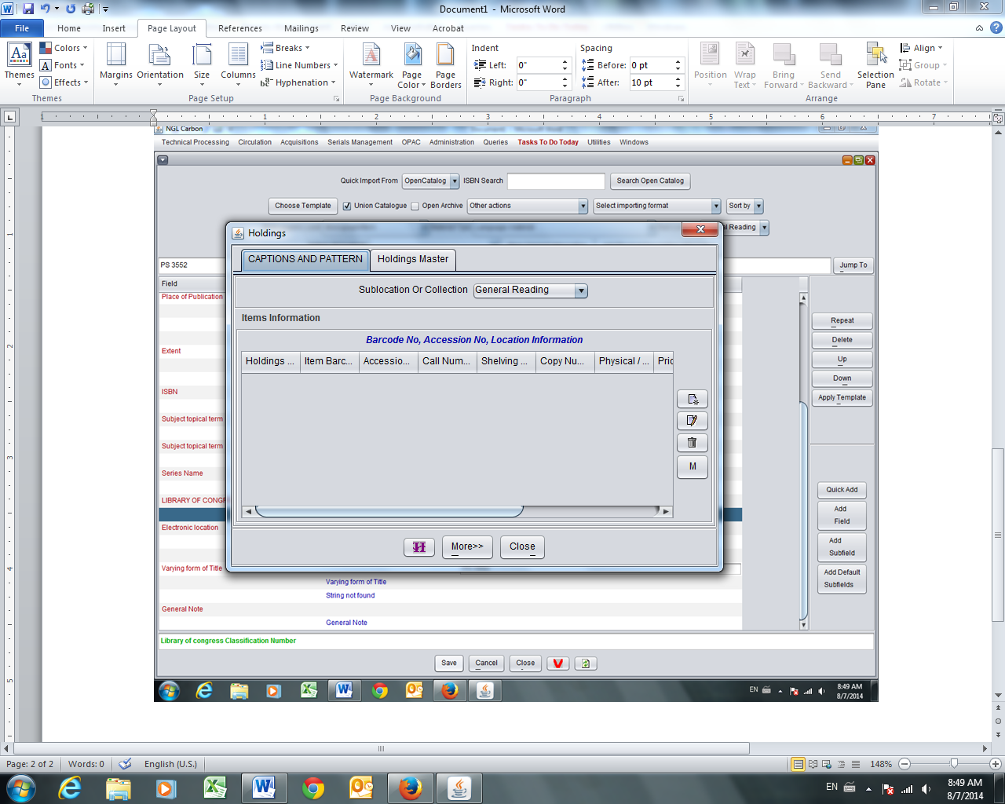
Screen C: Adding Holding

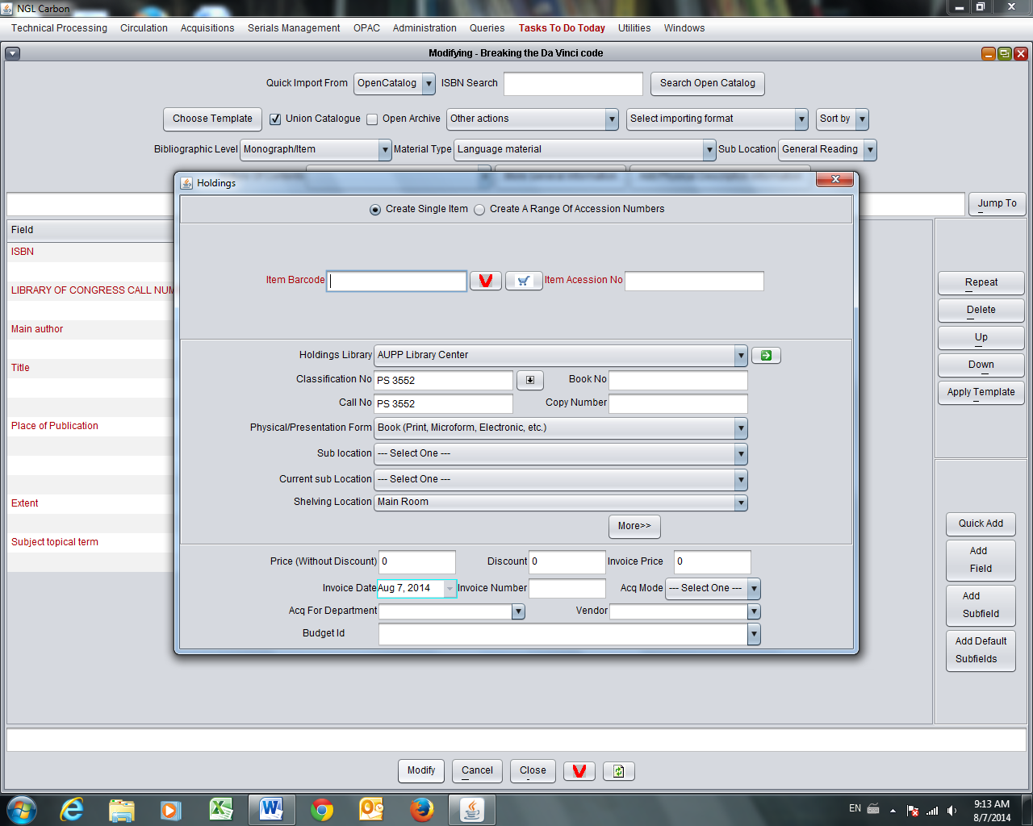
Screen D: Screen defaults with Classification No. PS 3552
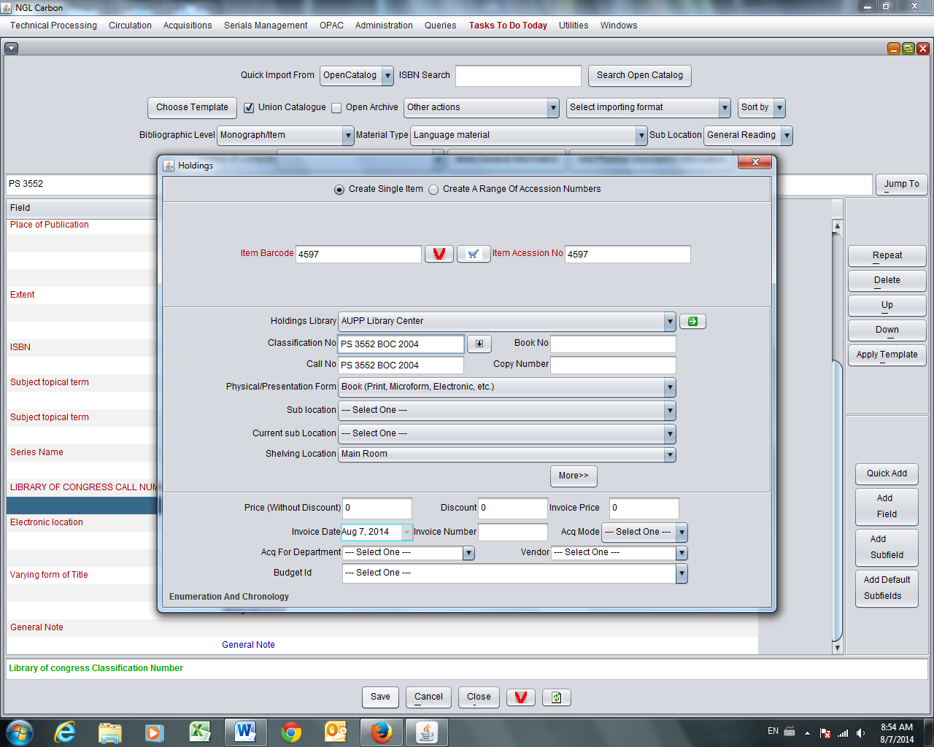
Screen E: Adding Barcode number; adding BOC 2004 after Classification number. Save.
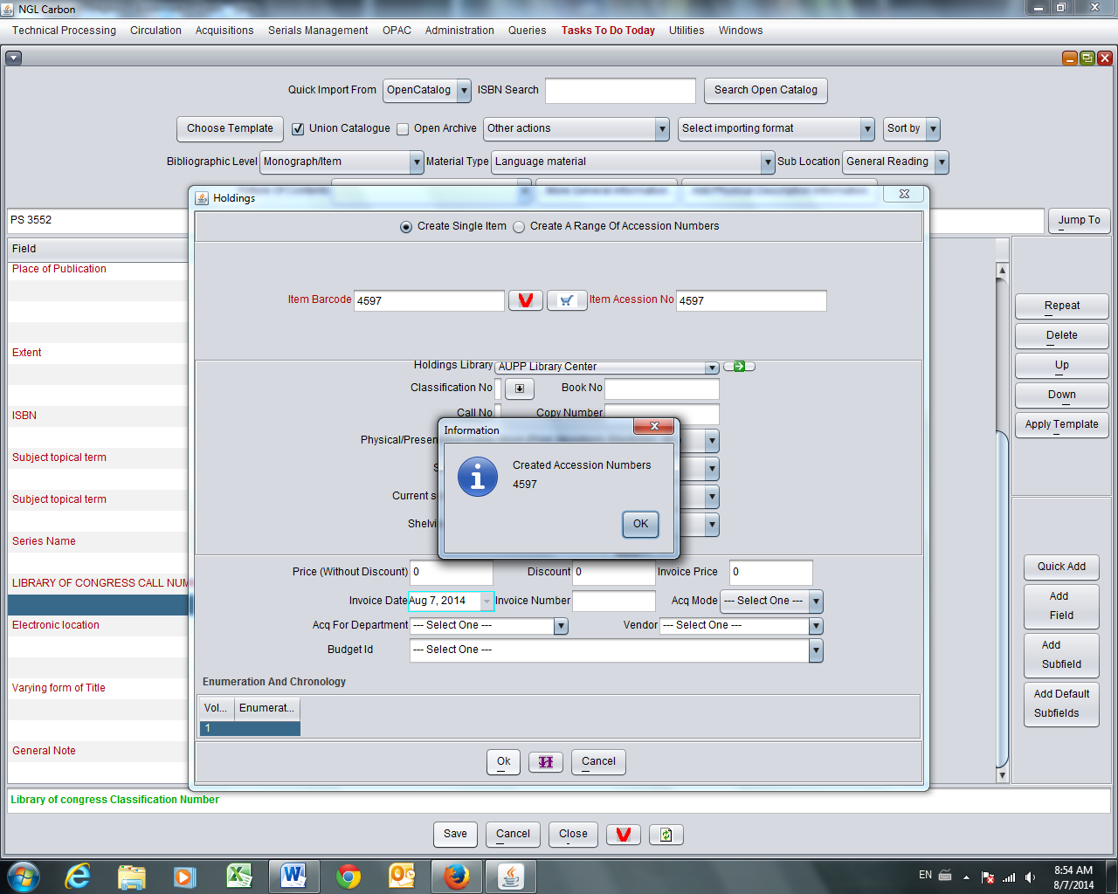
Screen F
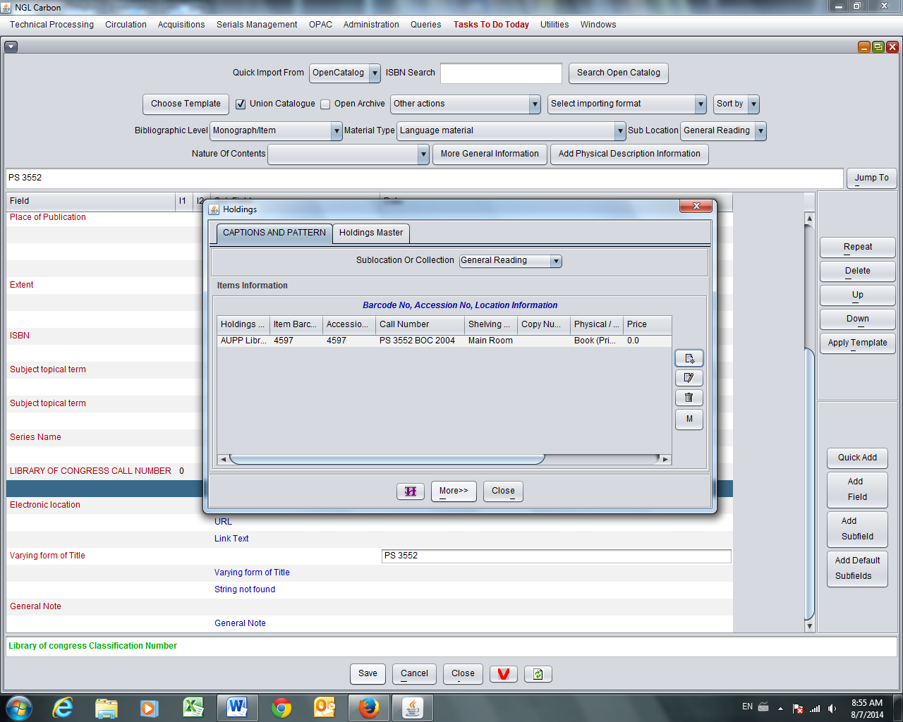
Screen G: After Save. Holdings screen showed Call Number with complete PS 3552 BOC 2004.

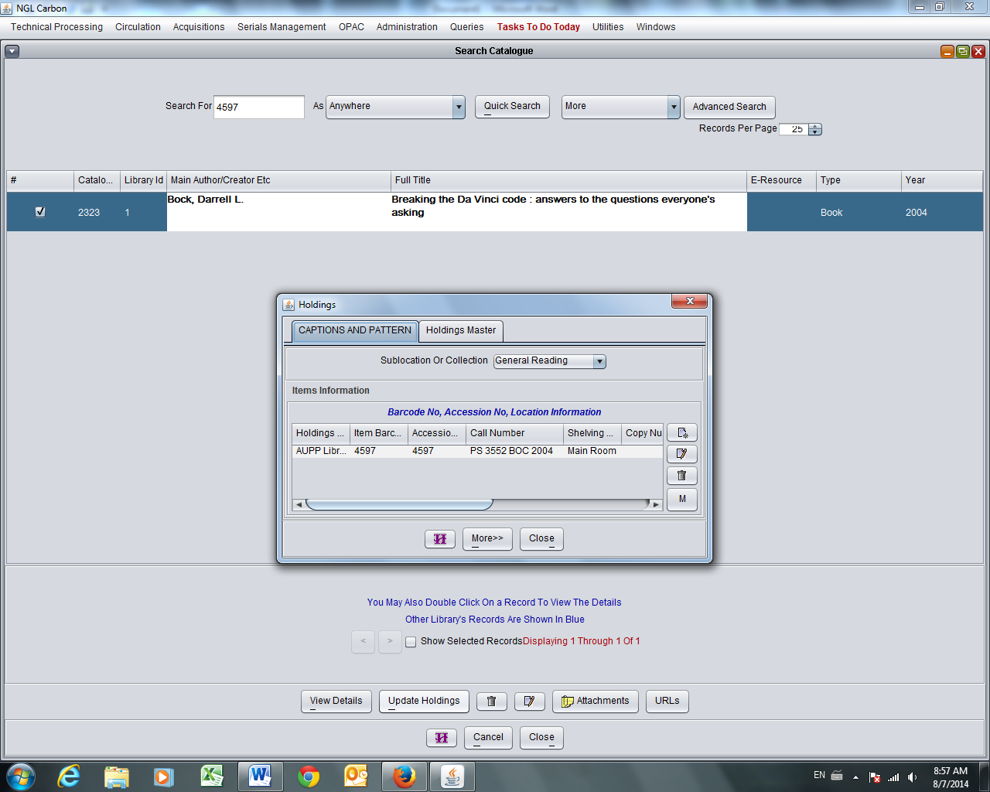
Screen H: On Search screen, Update Holdings shows complete Holdings same as after cataloguing, in screen above.

When we need to edit the record, the screen shows as in Screen D. omitting the extension BOC 2004.
Question: where does the extension go? Is it hidden somewhere? Do we use other options to keep the extension in view?
We tried to put the extension in Book No., it seems to stay ==> is this the appropriate place for extensions?

